DATA 500 Project Proposal
By: Ben Dupey, Isabella Pastorino, and Carly Hanes

Table of Contents
Introduction
Data Description
Initial EDA
Exploratory Questions
Next Steps
References
Introduction
Unidentified aerial phenomena (UFOs) have been reported for over a century, but most of what people think they know about UFOs comes from individual stories, movies, news cycles, and internet threads. Because of that, this topic is often treated like folklore instead of being handled like a data problem. Our goal is to treat it as a real analytical question. For this project, our group will be examining multiple relevant datasets, including UFO sighting data from Kaggle and other sources that may include geography, population, and atmospheric/environmental data. We are focusing on patterns in UFO sightings by exploring different variables around shape, location patterns, and potential correlations. The UFO topic is compelling because it mixes data quality issues, public reporting behavior, and the larger cultural question of how humans interpret unknown aerial objects. A lot of the current UFO discourse is based on anecdotes. Our goal is to approach this dataset as data analysts and identify actual patterns using exploratory data analysis before making any assumptions.
Using multiple datasets will allow us to see if sightings are simply higher where more people live, if reports spike during certain decades, or if there are geographic clusters that might indicate real-world explanations (airports, weather, technology) versus purely cultural reporting patterns.
Data Description
One part of this project looks at UFO sighting patterns over time. The goal is to see how reporting has changed from 1900 through 2024, identifying any periods of rapid increase, notable dips, or cultural and technological events that might align with spikes in sightings. Establishing these temporal trends provides a baseline for interpreting other patterns in the dataset. For instance, rises in reports during certain periods could reflect world events, aerospace developments, media coverage, or the spread of digital communication. By tracking year-by-year changes in sightings, the analysis helps determine whether later comparisons such as differences in shape or region of UFO’s should account for changes in overall reporting over time.
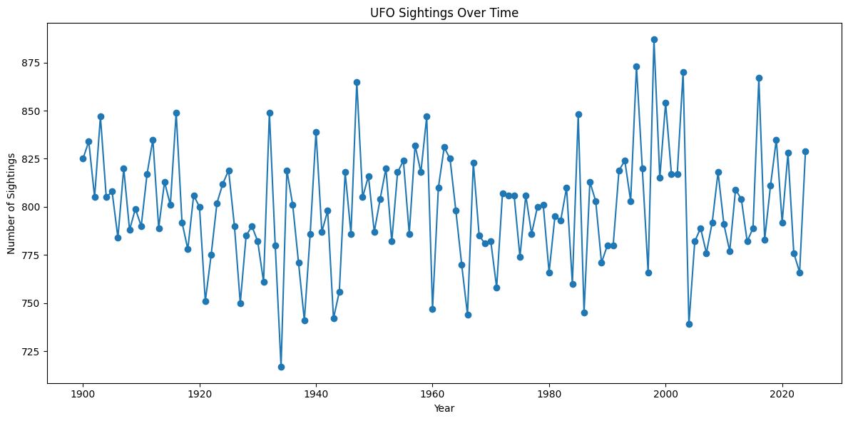
Visually, the chart shows a clear increase in reported sightings starting in the mid-1940s, with several noticeable peaks in the late 1950s, mid-1970s, and around the late 1990s to early 2000s. Between these peaks, there are periods of lower activity, reflecting dips in reporting. The overall trend demonstrates a general upward trajectory over time, suggesting that while occasional surges and declines occur, the total volume of sightings has grown steadily. This visual pattern supports the idea that temporal factors, such as historical events, media attention, and the advent of digital reporting, may influence how frequently sightings are recorded.

Data Dictionary: nuforc_highlights
-190,385 rows and 9 columns
-Midwest contains 28,275 rows
Column Name | Type | Description | Example
Link | Object | Originally contained a text link to Nuforc report, now uses placeholder in the CSV | Open !
Occurred | Object | Date and time sighting occurred | 10/06/2025 20:17
City | Object | Name of city or town the UFO was spotted | Joplin
State | Object | Two letter U.S. state abbreviation | MO
Country | Object | Country where sighting was reported | USA
Shape | Object | Reported shape of UFO | Disk
Summary | Object | Short text summary of the sighting by witness | Spinning lights changing color, 40 foot long flying saucer, no sound for being close by
Media | Object | Indicates if report included media, such as pictures or videos | Y or Missing Value
Explanation | Object | Nuforc’s classification of event | “Possible aircraft” but mostly Missing Value

Initial EDA

Questions

Next Steps

References.

